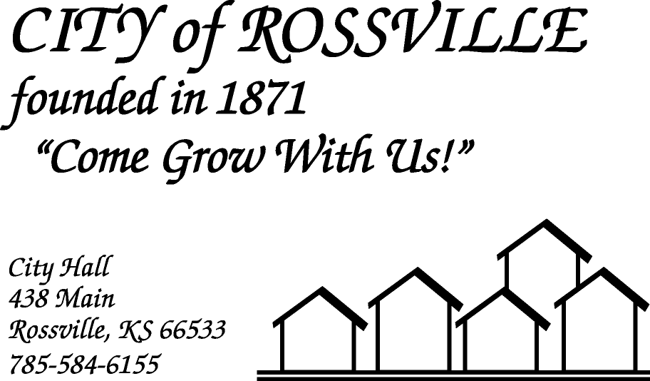

**AGENDA**

**MONDAY**

**AUGUST 17, 2020**

***AGENDA SUBJECT TO CHANGE***

7:00 pm 2021 BUDGET HEARING

7:05pm MINUTES

BILLS

ADOPT AGENDA

7:10 pm DAVID DEVORE-BG CONSULTANTS

Bathroom/storm shelter-City Park

7:25 pm COUNCIL REPORT

7:35 pm UTILITY DEPT REPORT/BUSINESS

7:45 pm POLICE DEPT REPORT/BUSINESS

7:55 pm OLD BUSINESS

Campbell Field/Stadium lease agreement w/ Beyond Baseball

Solid Waste Management Committee-Appointment

8:20 pm NEW BUSINESS

Water bill adjustment request-628 Griswold St.

8:30 pm ADJOURN

**NOTE: Due to COVID-19 the meeting will be online using ZOOM meeting service**

**Meeting ID: 890 0987 8045**

**Password: 613579**

**Please call City Hall at 785 584-6155 if you need assistance.**